**Kol Simcha Torah Gazette**

**For parshas bereishis 5786**

Vol 10 Issue 4 (Whole #468) 26 Tishrei 5786/ October 18, 2025

**Printed L’illuy nishmas Nechama bas R’ Noach, a”h**

For a free subscription, please forward your request to [***keren18@juno.com***](mailto:keren18@juno.com)

***Past emails can be found on the website ShabbosStories.com under Brooklyn Torah Gazette***

**Why Did Eve Listen**

**To the Snake?**

**By Rabbi** [**Yehuda Shurpin**](https://www.chabad.org/search/keyword_cdo/kid/15169/jewish/Shurpin-Yehuda.htm)

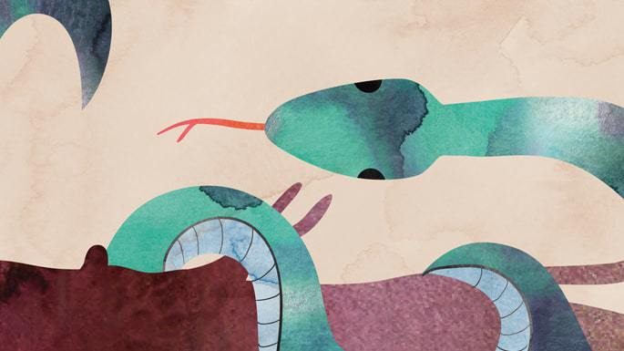

***Art by***[***Sefira Lightstone***](https://www.chabad.org/3159160)

Eve (Chavah in Hebrew) had just one commandment to keep: not to eat from the Tree of Knowledge. Yet she listened to the serpent, who told her to eat the forbidden fruit, and she then invited her husband, Adam, to do the same. It’s a tragic tale that has left many wondering, why did she even listen to the snake?

Before answering this question, it’s interesting to note that the Torah informs us that “the serpent was the shrewdest of all the wild beasts that G‑d had made . . .”[1](javascript:doFootnote('1a5668673');) indicating that the snake used his cunning to entice Eve to eat the forbidden fruit. Commentators explain that the arguments of the snake parallel the tactics our own evil inclination uses to entice us to sin. Through exploring the serpent’s subterfuge, we’ll also gain a better understanding of the workings of the evil inclination.

**Adding to**[**G‑d**](https://www.chabad.org/library/article_cdo/aid/433240/jewish/God.htm)**'s Word**

The Talmud[2](javascript:doFootnote('2a5668673');) points out that G‑d commanded Adam and Eve[3](javascript:doFootnote('3a5668673');) not to eat from the Tree of Knowledge. Yet, Eve told the serpent[4](javascript:doFootnote('4a5668673');) that G‑d had commanded them not to eat and not to touch the tree.

Although G‑d commanded Adam not to eat from the tree, Adam rationalized that by not *touching*the tree, they would be prevented from eating from it. So, when he repeated the command to Eve, he added that G‑d said not to touch it.[5](javascript:doFootnote('5a5668673');)

Hearing Eve’s words, the serpent cunningly pushed her into the tree, showing her that nothing would happen if she touched the tree—ergo, nothing would happen if she ate from it.

This, the [Talmud](https://www.chabad.org/library/article_cdo/aid/2537389/jewish/Talmud.htm) explains, teaches us that whoever adds to the [Torah](https://www.chabad.org/library/article_cdo/aid/1426382/jewish/Torah.htm) ends up subtracting from it. By erroneously attributing an added prohibition to G‑d, Eve ended up sinning and eating from the forbidden fruit.

**The Snake Ate First**

Eve was told that when she would eat from the Tree of Knowledge, she would die. Rabbi Don Isaac Abarbanel says that the snake challenged this by demonstrating that he could eat from the tree without any repercussions,[6](javascript:doFootnote('6a5668673');) which led Eve to speculate that the “real”[7](javascript:doFootnote('7a5668673');) reason behind the commandment was, as the snake claimed, that “G‑d knows that as soon as you eat of it your eyes will be opened and you will be like divine beings . . .”[8](javascript:doFootnote('8a5668673');)

(Interestingly, according to this explanation, the snake didn’t actually talk. Rather, it was through actions that intimated the message that is attributed to him in Scripture.)

**The Appeal of Forbidden Pleasure**

Rabbi Chaim ibn Attar, known as the Ohr Hachaim,[9](javascript:doFootnote('9a5668673');) explains that from the opening words of the serpent, we can glimpse some of the tactics he (and the evil inclination) used.

The snake opened by asking, “Did G‑d indeed say, ‘You shall not eat of any of the trees of the garden?’ ”[10](javascript:doFootnote('10a5668673');)

Now, what did he mean to say here? Surely, the serpent knew that all other trees were permitted. Rather, he was insinuating that all the fruit paled in comparison to the fruit of this tree, and as long as she did not taste its fruit it would be as if she never ate fruit of any tree at all.

Thus, the evil inclination works to simultaneously decrease one’s desire for the permitted while increasing one’s desire for the forbidden.

**“All Is Forbidden”**

Alternatively, the snake was suggesting that all the other trees in the Garden were planted from branches of the Tree of Knowledge. As such, he reasoned, they should really be forbidden to eat as well.

This is another way the evil inclination entices people. It attempts to magnify and intensify the challenge of doing mitzvahs, and it then turns around and convinces the person that due to the “insurmountable obstacles,” it is impossible to properly observe the [mitzvahs](https://www.chabad.org/library/article_cdo/aid/1438516/jewish/Mitzvah.htm).[11](javascript:doFootnote('11a5668673');)

**A Matter of Focus**

The Rebbe explains that the intent of the evil inclination is to cause a person to do the opposite of what G‑d wants. When the observance of a specific mitzvah takes on particular importance, the evil inclination makes an extra effort to prevent the person from doing that [mitzvah](https://www.chabad.org/library/article_cdo/aid/1438516/jewish/Mitzvah.htm). Thus, when Adam and Eve had but one mitzvah, the snake trained all of its power of enticement and seduction to get them to sin. In our own lives, when a specific mitzvah feels particularly difficult, that may be the very mitzvah we are meant to focus on.[12](javascript:doFootnote('12a5668673');)

**Knowing Better Than G‑d**

The Chassidic masters explain that Adam and Eve knew that their life in the Garden was meant to be an ongoing expansion of divine consciousness brought about by “cultivating and guarding.”

By suggesting to Eve that perhaps all the fruits were forbidden, the snake was trying to subtly plant in Eve’s mind the idea that perhaps G‑d meant to deprive them of the fullness of His creation and limit their ability to accomplish His ends. He was not letting them use every available means to make this world His home, in effect sabotaging their efforts. “If He has denied you this fruit, He may as well have denied you all fruit!” Thus, the snake convinced Eve that he knew better than G‑d Himself how to accomplish G‑d's ends.

This is another way the evil inclination usually works. It does not (initially, at least) attempt to convince us to sin, for we as humans are logical thinkers and would refuse. It instead convinces us that transgressing G‑d's express will is a shortcut to accomplishing G‑d's true purpose, and the supposedly sinful act is in fact meritorious.

Now that we know why Eve listened to the snake, we can better understand and be aware of the wily tricks of our own cunning snake, the evil inclination, and conquer it.

**Footnotes**

[1.](https://www.chabad.org/parshah/article_cdo/aid/5668673/jewish/Why-Did-Eve-Listen-to-the-Snake.htm" \l "footnoteRef1a5668673) [Genesis 3:1](https://www.chabad.org/library/bible_cdo/aid/8167/jewish/Chapter-3.htm#v1). [2.](https://www.chabad.org/parshah/article_cdo/aid/5668673/jewish/Why-Did-Eve-Listen-to-the-Snake.htm#footnoteRef2a5668673) Talmud, [Sanhedrin 29a](https://www.chabad.org/torah-texts/5458041/The-Talmud/Sanhedrin/Chapter-3/29a). [3.](https://www.chabad.org/parshah/article_cdo/aid/5668673/jewish/Why-Did-Eve-Listen-to-the-Snake.htm#footnoteRef3a5668673) [Genesis 2:17](https://www.chabad.org/library/bible_cdo/aid/8166/jewish/Chapter-2.htm#v17). [4.](https://www.chabad.org/parshah/article_cdo/aid/5668673/jewish/Why-Did-Eve-Listen-to-the-Snake.htm#footnoteRef4a5668673) [Genesis 3:3](https://www.chabad.org/library/bible_cdo/aid/8167/jewish/Chapter-3.htm#v3).

[5.](https://www.chabad.org/parshah/article_cdo/aid/5668673/jewish/Why-Did-Eve-Listen-to-the-Snake.htm" \l "footnoteRef5a5668673) There is a debate among the commentaries whether it was Adam or Eve who added to G‑d’s words; see commentaries on [Genesis 3:3](https://www.chabad.org/library/bible_cdo/aid/8167/jewish/Chapter-3.htm#v3).

[6.](https://www.chabad.org/parshah/article_cdo/aid/5668673/jewish/Why-Did-Eve-Listen-to-the-Snake.htm" \l "footnoteRef6a5668673) See *Abarbanel*on Genesis 3.

[7.](https://www.chabad.org/parshah/article_cdo/aid/5668673/jewish/Why-Did-Eve-Listen-to-the-Snake.htm" \l "footnoteRef7a5668673) It should be noted that we are in fact meant to try to understand the reasons behind the mitzvahs. However, it is critical to keep in mind that ultimately we keep the mitzvahs because we were commanded to do so by G‑d, regardless of where our own finite speculations have led us.

[8.](https://www.chabad.org/parshah/article_cdo/aid/5668673/jewish/Why-Did-Eve-Listen-to-the-Snake.htm" \l "footnoteRef8a5668673) [Genesis 3:5](https://www.chabad.org/library/bible_cdo/aid/8167/jewish/Chapter-3.htm#v5). [9.](https://www.chabad.org/parshah/article_cdo/aid/5668673/jewish/Why-Did-Eve-Listen-to-the-Snake.htm#footnoteRef9a5668673) *Ohr Hachaim*on [Genesis 3:1](https://www.chabad.org/library/bible_cdo/aid/8167/jewish/Chapter-3.htm#v1). [10.](https://www.chabad.org/parshah/article_cdo/aid/5668673/jewish/Why-Did-Eve-Listen-to-the-Snake.htm#footnoteRef10a5668673) [Genesis 3:1](https://www.chabad.org/library/bible_cdo/aid/8167/jewish/Chapter-3.htm#v1). [11.](https://www.chabad.org/parshah/article_cdo/aid/5668673/jewish/Why-Did-Eve-Listen-to-the-Snake.htm#footnoteRef11a5668673) See *Ohr Hachaim* on [Genesis 3:1](https://www.chabad.org/library/bible_cdo/aid/8167/jewish/Chapter-3.htm#v1).

[12.](https://www.chabad.org/parshah/article_cdo/aid/5668673/jewish/Why-Did-Eve-Listen-to-the-Snake.htm" \l "footnoteRef12a5668673) See *Likkutei Sichot,*vol. 3, p. 747.

*Reprinted from the Chabad.Org website.*

**In Manchester, Waking**

**Up to a Different World**

**By**[**Ilana Kendal**](https://aish.com/authors/48869302)



In Manchester on Yom Kippur, a mother races her children home under lockdown—praying, remembering, and asking: how do we wake up to a world that keeps changing around us?

Today I woke up to a different world. The [Manchester](https://aish.com/yom-kippur-attack-in-manchester/) I live in feels different this morning.

It’s not the first time this has happened to me. I was on the last airplane allowed into Israeli airspace on September 11th - the next day I awoke to a different world. I lived in Jerusalem during the second intifada - I awoke to a different world many times. Like the rest of the world, I too woke up October 8th to a different world.

And so today, as I look out my kitchen window at the typical Manchester drizzle, the world is different once again.

Yesterday, Yom Kippur, I set out mid-morning with my three little boys. I had seen the helicopters in the air and my boys asked about them. I wasn’t sure but we headed out anyway. Then we saw more police cars and were told we had to turn around and go home; there had been a stabbing at a nearby shul and all the shuls were going into lockdown.

I told my boys they had to stay close and walk very quickly. With my heart racing I set back towards home. I remembered my Bubbie saying that when she walked home late at night in Lodz before the war, if she was scared she said [the Shema](https://aish.com/shema-yisrael-2/) over and over. So I recited the Shema to myself as we raced back.

My boys had thought the policeman said “knocked down” instead of “locked down” and kept asking why all the shuls had to be knocked down. We got home and watched all the helicopters that stayed in the sky all day. Slowly the news trickled in. Slowly the streets were more populated and we ventured out. And slowly I’m trying to make sense of what this means for us here, in Manchester, in the UK and for our world.

**We Are Still Sleeping**

Slovie Jungreis Wolff quotes her mother, the Hungarian Holocaust survivor Esther Jungreis z”l as saying in her later years: “I know what I’ve seen. I know where I’ve been. We are sleeping.”

The call of the shofar over the past 40 days has been meant to serve as an existential alarm clock. And yet, there was nothing like the wakeup call yesterday. The world feels different today but I’m not sure it actually is. Our mission was and is to understand that this is not the first time we have been under threat as Jews. And it is not the first time the Almighty has tried to get our attention.

I tried to reassure my kids. I stayed in the back garden with them when they were frightened and let them know there would be extra police at school today. “Good news!” my 6-year-old told his dad. “There will be policemen at school today!” But if we leave it at that, the focus on antisemitism, the questions about communicating to children and processing trauma, I believe we are missing the call.

The Talmud says that when there is a tragedy it is incumbent on each individual to examine their own deeds - how they are behaving and showing up in life. What each of us do in the private quarters of our lives, what we choose to change and grow, matters.

My world is feeling wobbly and I believe the way forward and out of this darkness is not merely a political path; it’s taking to heart the personal wakeup call that I just received.

I pray we stop waking up to different worlds, that we need not say Shema under our breath or ask how to talk to our kids about such terror. Until then I will do my best to ask myself: Where can I change and do better? To do my part in helping to bring the world out of this darkness.

Dedicated to the refuah shelaima of Yehonasan Zalman ben Shaina Gittel and Anshel Yitzchak ben Malka

*Reprinted from the current website of aish.com*

**Rav Avigdor Miller on**

**Praying to the G-d of Israel**

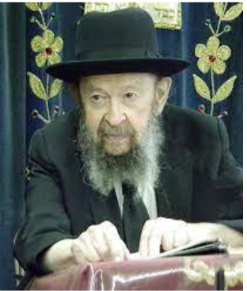

**QUESTION:** Is it possible for a Muslim or a Christian to love Hashem?

**ANSWER:** It depends on what he is loving. I must tell you that it makes a very big difference what the gentile is thinking when he talks about his god. When somebody wants to talk about a certain personality, a G-d, he has to know that the personality must be designated by a certain description. And that designation makes all the difference in the world.

Suppose you want to bring a gift to somebody, but you don’t know who you’re bringing it to, so you bring it to the man next door. It might be a beautiful gift, but you brought it to the wrong address. So, when people pray to a god that spoke to Mohammed, then they’re praying to the wrong god, because there is no such god. If they declare that “Allah is god and Mohammed is his prophet,” they’re talking about a different god that doesn’t exist.

If people pray to a god that was supposedly born from a mother, then they’re talking about something that doesn’t exist. And therefore, they are idolaters, or at best they’re praying to zero, to something that doesn’t exist. They get no reward at all. They’re not loving Hashem, they’re praying to nothing, to a made-up god. Prayer is only real prayer if it’s directed at *Hashem Elokei Yisroel.*

And that’s the Rambam’s statement. It says that the *chasidei umos haolam*, the righteous gentiles, have a share in the World to Come. However, the Rambam says that they must recognize that Hashem is the *Elokei Yisroel,* that He is the G-d of Yisroel. He has chosen us! He chose the Am Yisroel. Only if they believe that, can they be included in the category of *chasidei umos haolam.*

Pharaoh was willing to believe in Hashem when Moshe came to him, but he wasn’t willing to believe in *Hashem Elokei Yisroel.* And that was the big problem! And so, Hashem got busy demonstrating not only that He is Hashem, but that He is *Hashem Elokei Yisroel.*

And that’s why it’s so important to believe the right things about Hashem. If a Jew believes in a universal god, then he’s not a Jew. Certainly, Hashem is the Master of the Universe, but He has declared that the universe was made because of His people, the Am Yisroel. And so,  we are the main actor on the stage of history and the entire world is nothing but the backdrop and scenery for us. And no matter how difficult a concept that is for you, you’re going to have to learn it. Because we have to live up to that responsibility! And you can only do that if you realize that we are the main performers in this world, and that Hashem has chosen us, and He has declared that He is *Hashem Elokei Yisroel.*

*Reprinted from a recent email of Torah Avigdor based on a lecture delivered on. Februrary 1991).*

**Recognizing that Every Detail in Life is Part of the Divine Plan Which a Jew Can Make Holy**

**From the Teachings of the Lubavitcher Rebbe**

**Rabbi Menachem Mendel Schneerson, Zt”l**

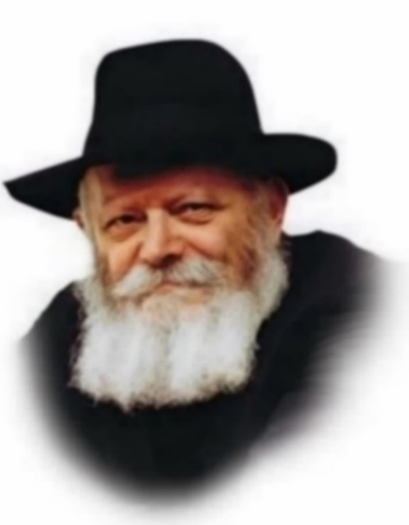

"In the beginning G-d created the heaven and the earth." With these momentous words, the very first portion of the Torah, Bereishit, establish G-d's Kingship over all of creation.

The Torah, however, is not a history book. The Torah is our guidebook. We can apply its teachings to every aspect of our existence.

The ancient Sage, Rabbi Yitzchak, raises a pertinent question. "Why does the Torah open with the story of Creation?" he asks, as quoted by Rashi in his commentary. "Why didn't G-d begin with the words, 'This month is to you,'- the first commandment containing practical implications?"

"The might of His deeds He told to His nation; to bequeath to them the heritage of the nations," Rabbi Yitzchak himself answers.

"If the nations of the world will one day accuse the Jewish people of being thieves, having 'stolen' the land of Israel from the seven nations who formerly inhabited it, they will counter, 'The entire earth belongs to G-d! He is the One Who created it and bequeathed it to whom He saw fit. It was His will to give the land to the nations; it was His will to take it from them and give it to us."

According to this explanation, the entire order of the Torah's portions was changed solely to refute the world's complaint that the Jewish people misappropriated their land. But is their accusation really so important that G-d would change even one letter in His holy Torah for its sake? Would not a refutation in the Oral Tradition have been sufficient to counter whatever complaint Gentiles would one day lodge against the nation of Israel?

In truth, the Torah's choice of language holds significance not only for the nations of the world but for Jews themselves.

"In the beginning" contains an important lesson for every Jew to apply in his daily life.

In general, the life of a Jew may be divided into two realms: the religious and the secular.

The Jew willingly observes his various religious obligations because the Torah requires him to.

When, however, he is asked to also sanctify those mundane aspects of daily existence that seemingly fall outside the domain of religious observance, he balks, rejecting this demand as an invasion of privacy.

The secular realm of a person's life, pertaining to the physical and material domain, metaphorically belong to the "seven nations."

Yet it is precisely this realm that the Jew is called upon to conquer, elevating his every action by performing it solely for the sake of heaven.

"You are thieves!" the world cries out against the Jew. "How dare you conquer the domain of the seven nations and blur the distinction between religious observance and the mundane?!"

To which the Jew replies, "All of creation belongs to G-d." Every realm of existence is part of Divine plan and can be made holy.

Indeed, such is the mission of every Jew -- to transform wherever he may be into a spiritual Land of Israel.

Judaism demands that we sanctify even the lowest aspects of the material world, thereby imbuing all of creation with holiness and demonstrating the unity of the One Creator.

*Reprinted from the Parashat Bereishis 5763/2002 edition of L’Chaim, a publication of the Lubavitch Youth Organization. Adapted from Likutei Sichot of the Rebbe, Vol. 20*

**Two Dead, Three Injured in Terror Attack at Manchester Synagogue on Yom Kippur**

**By**[**Moshe New**](https://www.chabad.org/search/keyword_cdo/kid/31757/jewish/New-Moshe.htm)

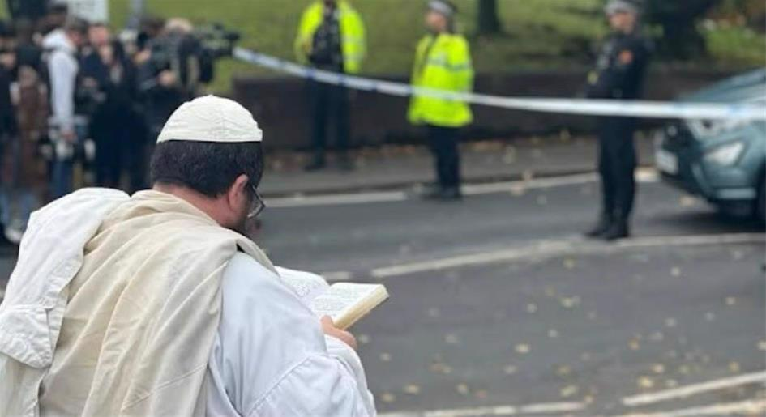

**Praying in traditional Yom Kippur garb outside the scene of the horrific attack.**

A terrorist launched a car-ramming and knife attack outside the Heaton Park Hebrew Congregation synagogue in Manchester during [Yom Kippur](https://www.chabad.org/library/article_cdo/aid/177886/jewish/What-Is-Yom-Kippur.htm) morning prayer services on Thursday, October 2, killing two people and seriously injuring three others. The attacker, identified as Jihad Al-Shamie, a 35-year-old British citizen of Syrian descent, was shot dead by police officers at the scene.

The attack occurred around 9:30 a.m. as congregants were gathering for morning prayers on Yom Kippur, when Jews worldwide fast for 25 hours and spend the day praying. The terrorist first rammed his vehicle into people outside the synagogue before exiting with a knife and what appeared to be an explosive vest, which was later determined to be fake.

In an extraordinary act of courage that undoubtedly saved many lives, Rabbi Daniel Walker, the Chabad rabbi who leads the congregation, immediately recognized the danger and barricaded the synagogue doors, preventing the attacker from entering the sanctuary where the worshippers had gathered.

“Rabbi Walker was incredibly calm, he shut the doors to the synagogue to stop him getting inside,” Chava Lewin told local press. “He barricaded everyone inside. He is a hero; this could have been even worse.”

Witnesses described how the rabbi, despite visible bloodstains on his clothing from helping victims, maintained remarkable composure as he secured the building and moved congregants to safety while armed police responded to the scene.



**Rabbi Daniel Walker is widely regarded as a hero who saved many lives.**

The attack comes amid a sharp rise in antisemitic incidents across the United Kingdom following the October 7, 2023, attacks in Israel. Jewish communities have faced increasing threats and violence.

Yet the Jewish response has been one of defiance through faith. A [Chabad](https://www.chabad.org/library/article_cdo/aid/244369/jewish/About-Chabad-Lubavitch.htm) rabbi in Epping, near London, shared words a community member shared with him after their prayer services: “I was in two minds about coming this [Yom Kippur](https://www.chabad.org/library/article_cdo/aid/4687/jewish/Yom-Kippur-2025.htm) to shul. But after seeing what happened in Manchester, I told my wife, ‘I gotta go.’ ”

Rabbi Bentzi Sudak of Chabad of Hampstead Garden shared a similar anecdote from an elderly community member, a woman who had not been attending services, as it was too hard for her. When she heard of the attack, she told her son, “They attacked a shul; we’re going to shul.”

“In her eyes, I saw the power of generations of Jews who responded: “A shul is attacked; I'm going to shul,” the rabbi said.

**National Response and Increased Security**

Prime Minister Keir Starmer condemned the attack in the strongest terms, stating that the terrorist “attacked Jews because they are Jews,” and pledged that such hatred “will not stand” in Britain. King Charles III also expressed his support for the Jewish community, joining other leaders in condemning the violence.

Greater Manchester Police immediately declared the incident a terrorist attack and activated Operation Plato, their protocol for marauding terrorist incidents. Assistant Chief Constable Rob Potts confirmed that three additional suspects—two men in their 30s and one woman—were arrested in connection with the attack.

Police presence has been significantly increased at all synagogues across Greater Manchester and throughout the United Kingdom.

The global Jewish community is asked to recite Psalms for the recovery of those injured in the attack and for the elevation of the souls of those killed. C[hapter 20 of Psalms](https://www.chabad.org/library/bible_cdo/aid/16241/jewish/Chapter-20.htm), traditionally recited in times of distress, is particularly appropriate.

Community members are also encouraged to dedicate additional Torah study in memory of the victims; perform acts of kindness and [charity](https://www.chabad.org/library/article_cdo/aid/4203668/jewish/What-Is-Tzedakah.htm); attend synagogue services with renewed commitment; place charity boxes in homes and workplaces; and light [Shabbat candles](https://www.chabad.org/library/article_cdo/aid/87131/jewish/How-to-Light-Shabbat-Candles.htm) (for women and girls) with special intention for increased light in the world.

*May the memories of those killed sanctify G‑d’s name, and may those injured have a complete and speedy recovery.*

*Reprinted from the Chabad.Org website.*